LAB EXPERIMENT RECORD
Set 6: Product Sales Analysis

Department | AIML
Course Code / Course Name | DSA0601 / Data Handling and Visualization
Experiment | Data Visualization using R and Tableau
Name | G. Ganga Chandrika
Register Number | 1925260144
Date | 1 October 2026
Day | Thursday

Aim
To visualize the monthly product sales data using a grouped bar chart, a stacked area chart, and a data table in R, and to build an interactive dashboard using Tableau.
Dataset: Monthly Product Sales
Product ID | Product Name | January Sales | February Sales | March Sales
1 | Product A | 2000 | 2200 | 2400
2 | Product B | 1500 | 1800 | 1600
3 | Product C | 1200 | 1400 | 1100
PROGRAM 1: Grouped Bar Chart of First Quarter Sales
Create a grouped bar chart to visualize the sales of each product for the first quarter. Label the chart elements.
# Load packages
library(ggplot2)
library(tidyr)
# Dataset
sales <- data.frame(
Product = c("Product A", "Product B", "Product C"),
January = c(2000, 1500, 1200),
February = c(2200, 1800, 1400),
March = c(2400, 1600, 1100)
)
# Convert data into long format
sales_long <- pivot_longer(
sales,
cols = January:March,
names_to = "Month",
values_to = "Sales"
)
# Create grouped bar chart
ggplot(sales_long, aes(x = Product, y = Sales, fill = Month)) +
geom_bar(stat = "identity", position = "dodge") +
geom_text(
aes(label = Sales),
position = position_dodge(width = 0.9),
vjust = -0.3
) +
labs(
title = "Product Sales for First Quarter",
x = "Product",
y = "Sales",
fill = "Month"
) +
theme_minimal()
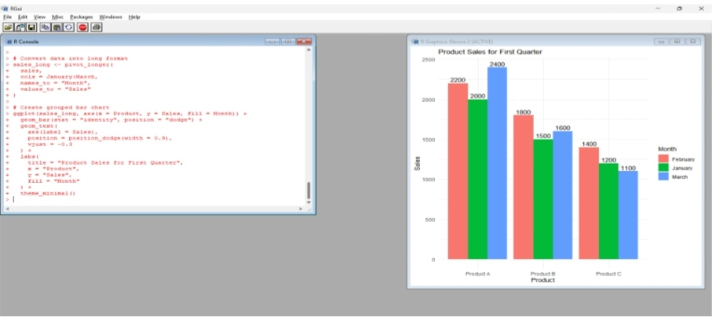
Output 1: Product Sales for First Quarter – Grouped Bar Chart
Observation: Product A has the highest sales in every month and increases steadily from 2000 to 2400. Product B rises from 1500 to 1800 in February and then falls to 1600 in March. Product C rises to 1400 in February and drops to 1100 in March, the lowest value in the dataset.
PROGRAM 2: Stacked Area Chart of Overall Sales Trend
Generate a stacked area chart to represent the overall sales trend for all products over the three months.
# Keep the months in calendar order
sales_long$Month <- factor(sales_long$Month,
levels = c("January", "February", "March"))
# Create stacked area chart
ggplot(sales_long, aes(x = Month,
y = Sales,
fill = Product,
group = Product)) +
geom_area(alpha = 0.8) +
labs(
title = "Overall Sales Trend of All Products",
x = "Month",
y = "Sales",
fill = "Product"
) +
theme_minimal()
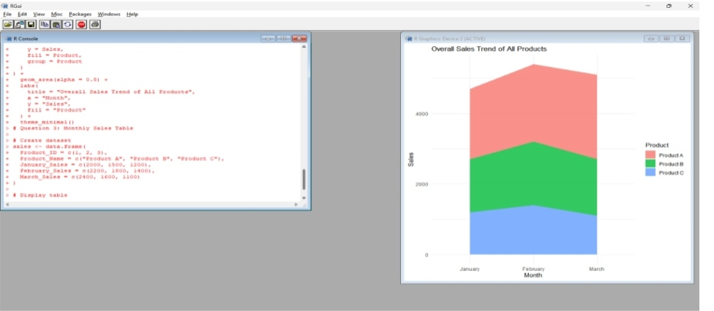
Output 2: Overall Sales Trend – Stacked Area Chart
Observation: The combined sales of all products are 4700 in January, 5400 in February, and 5100 in March. The overall trend rises to a peak in February and then declines slightly in March.
PROGRAM 3: Monthly Product Sales Table
Build a table to show the monthly sales data for each product. Label the table elements.
# Create dataset
sales <- data.frame(
Product_ID = c(1, 2, 3),
Product_Name = c("Product A", "Product B", "Product C"),
January_Sales = c(2000, 1500, 1200),
February_Sales = c(2200, 1800, 1400),
March_Sales = c(2400, 1600, 1100)
)
# Display table
print(sales)
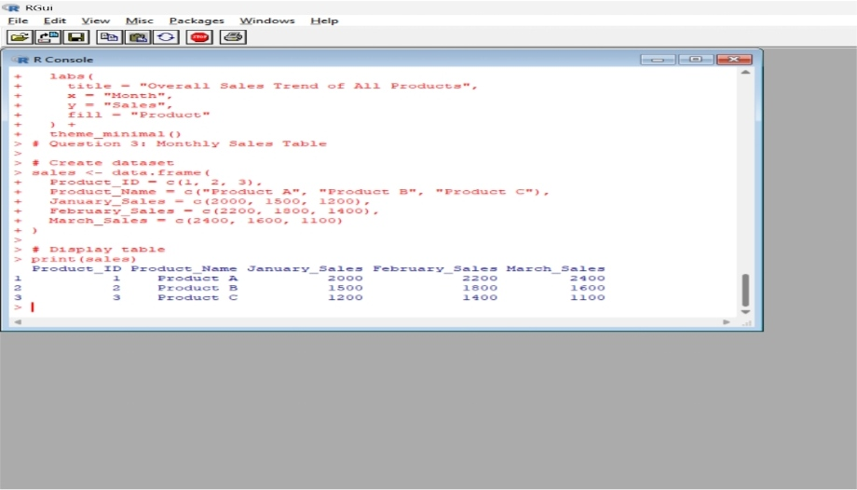
Output 3: Monthly Product Sales Table
Observation: The table lists the product ID, product name, and the sales for January, February, and March, with each column labelled. It makes the exact monthly value of every product easy to read.
PROGRAM 4: Tableau Dashboard
Develop a Tableau dashboard combining the grouped bar chart, stacked area chart, and table for interactive exploration of sales data.
Data Preparation
The dataset was entered in an Excel workbook (Product Name, January Sales, February Sales, March Sales) and a column chart of the sales was prepared. The workbook was then used as the data source in Tableau.
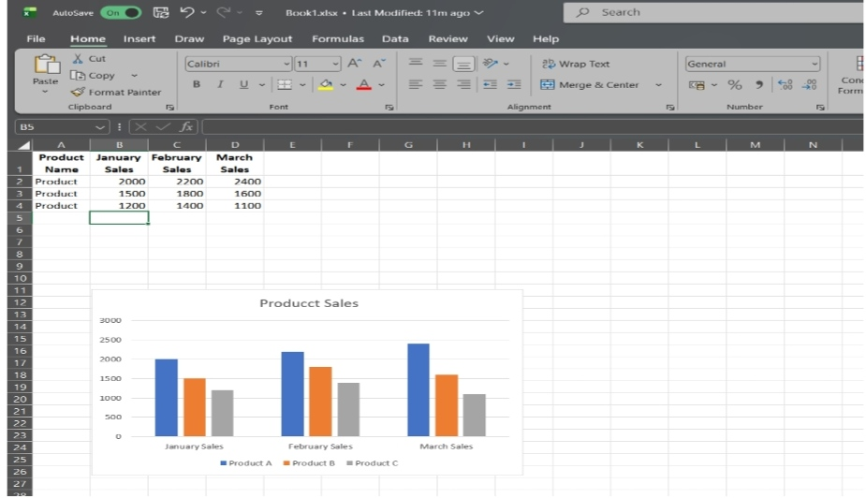
Output 4: Product Sales Data and Chart in Excel (Data Source for the Tableau Dashboard)
Dashboard Steps
1. Open Tableau and connect to the Excel workbook containing the monthly product sales data.
2. Pivot the January, February, and March Sales columns to create the fields Month and Sales.
3. Sheet 1 (Grouped Bar Chart): place Product Name on Columns, Sales on Rows, and Month on Color and Label.
4. Sheet 2 (Stacked Area Chart): place Month on Columns, Sales on Rows, set the mark type to Area, and place Product Name on Color.
5. Sheet 3 (Table): place Product Name on Rows, Month on Columns, and Sales on Text.
6. Create a new Dashboard, drag Sheet 1, Sheet 2, and Sheet 3 onto it, and give the dashboard a title.
7. Add a Product Name filter and use the charts as filters (Use as Filter) so that selecting a product updates all three views.
Observation: The dashboard brings the grouped bar chart, stacked area chart, and table into one view, so a product or month can be selected and all three sheets update together.
Procedure
1. Create the monthly product sales data frame in R.
2. Install and load the ggplot2 and tidyr packages.
3. Convert the data to long format using pivot_longer() and draw the grouped bar chart using geom_bar() with position = "dodge".
4. Use geom_area() on the long-format data to draw the stacked area chart of overall sales.
5. Create the data frame with Product_ID, Product_Name, and the three monthly sales columns, and display it using print().
6. Load the dataset into Tableau, build the three sheets, and combine them in a dashboard with filters for interactive exploration.
Result
The first-quarter product sales data was successfully visualized in R using a grouped bar chart, a stacked area chart, and a table. A Tableau dashboard combining all three views was developed for interactive exploration of the sales data.
Key R Functions Used
Function | Purpose
data.frame() | Creates the product sales dataset
pivot_longer() | Converts month columns into long format
ggplot() | Initializes the chart with aesthetic mappings
geom_bar() | Draws the grouped bars (position = "dodge")
geom_text() | Adds sales value labels above the bars
geom_area() | Draws the stacked area chart
labs() | Sets the title, axis labels, and legend title
print() | Displays the table in the R console

